Concentrations

# Introduction

Originally, the main target of the ECO-WISE team was to perform concentration measurements for Carbon Dioxide (CO2) and Ozone (O3) throughout the flight and thus build a profile for these two substances starting from the ground and reaching to early stratospheric altitudes. For that purpose, a pair of Infrared Gas Sensors (IR11BD) and a pair of Oxidizing Gas Sensors (OX-BX431) were used. However, these components are normally meant to operate on ground level and not on environments with constantly decreasing operating pressure and temperature. So, a structure which would suck, pressurize, and heat air to the desired amounts through a pump had to be built to artificially produce the suitable conditions. Unfortunately, due to a pressure leak and, as was explained in the previous segments, a wrongful pump choice the sensorbox was not sufficiently pressurized during most of its measurement cycles and as a result the validity of the concentrations given by the sensors at best cannot be ensured and at worst is entirely false. Additionally, no calibration procedures took place and thus the measurements cannot be used to produce a quantitative profile as was intended. Instead, an attempt was made to create a qualitative image for the gases. Each pair of sensors had different operating requirements and calculating sequences. A summary of those as well as a short presentation of the final findings is shown in the following paragraphs.

# OX-B431 (O3 Sensor)

#### Environmental Performance Ranges

The sensor’s technical specifications manual indicates the pressure, temperature, and humidity ranges needed for its proper function. These three environmental variables were continuously monitored inside and outside the sensorbox and a thorough examination was completed in the Environmental and Experiment conditions segment. Firstly, the relative humidity inside the sensorbox was within 15-85 % only for the duration of the first few cycles. Afterwards, as can be seen in the graph below, RH% was always clearly below 15% during the measurement phase of each cycle.

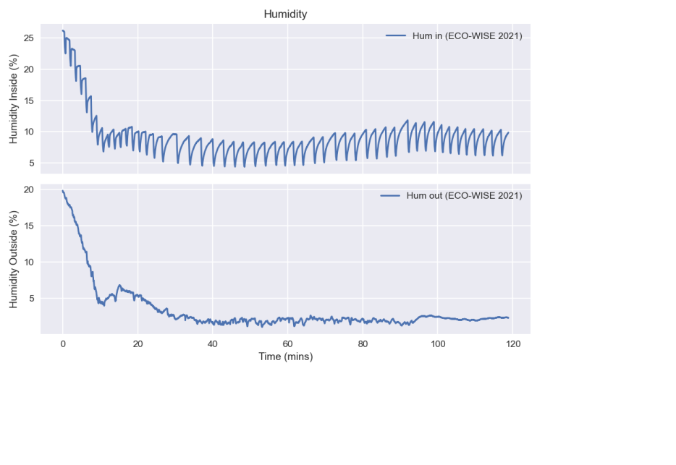

Graph 1: Humidity Inside and Outside the Sensorbox as measured by ECO-WISE

Moreover, OX-B431 has an 800-1200 mbar functional pressure range. As was discussed in a previous section, such pressure was only achieved for about the first 40 minutes of flight, when the ambient pressure was greater than 280 mbar.

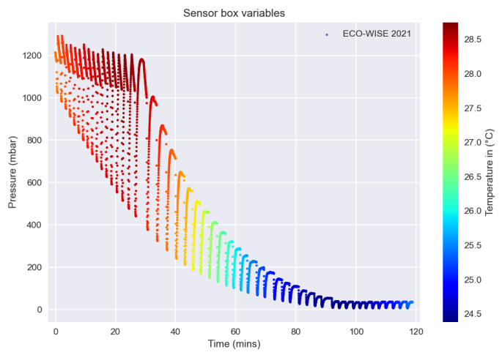

Graph 2: As can clearly be seen in the above graph, the inside pressure was not sufficient for a great part of the flight

Conversely, the temperature inside the sensorbox remained remarkably stable between 24 oC and 30 oC as has been previously shown. This temperature stability not only ensures that the sensors were inside their operating range, but it made the temperature compensation much simpler. Conclusively, for most of their operating phase, the two electrochemical sensors did not function inside their desired environmental ranges and their findings cannot be deemed reliable. Another possible, but not necessarily correct, way to interpret this result is that a great increase in the error margins for the measurements must be added.

#### Calibration Procedure

An integral part of converting the voltage measurements (Working Electrode and Auxilliary Electrode) given by the sensors into O3 concentration is the proper and multi-layered calibration procedure. There are 2 main sets of currents which must be accounted for and measured separately in a known concentration environment. The first is a DC Voltage offset (the terms voltage and current are used interchangeably) on the electronics of the sensor which remains practically unchanged. Typical values are given for this offset by the manufacturer, but more accurate calculations are made during the calibration. The second set of currents is entirely due to the sensors and must be measured separately during the calibration as it is not stable at all. Due to the very low concentration of ozone in the atmosphere the measurements are comparable to these offsets and noise currents and thus it is impossible to make accurate measurements without having proper knowledge of them. Another important factor which must be considered during the final calculations is the temperature compensation. In this case, due to the stability of the temperature in the sensorbox, one multiplication factor given by the manufacturer is enough to produce acceptable results.

#### Necessary Functional Approximations and Oversights with smaller contributions

Regardless of the calibration procedure approximations that unavoidably had to been made, there are two main initial assumptions under which the O3 concentration measurements are made. The first is the fact that the OX-B431 sensor measures the NO2 and O3 concentrations combined. Considering that NO2 appears in much smaller quantities than O3 and mostly in the lower levels of the atmosphere (due to its connection to human pollution) its contribution to the sensors’ output can be ignored ( small increase in the uncertainty of the measurements). The second approximation which negatively affects the validity of the given results is the algorithm used to convert the voltage readings given by the sensors to concentration. The application notes provide multiple methods to compensate for the existing background currents and the temperature in order to calculate the O3 concentration. Given the ozone’s small concentration, the measurements are a lot of times comparable to the background currents and thus there exists the possibility that the used algorithm greatly overcompensates. A somewhat better algorithm selection could have perhaps been made if the sensors had been calibrated but the issue would be persistent regardless. For the graph presented below the following algorithm was used instead of the one mentioned in chapter 8.9.



Where WEC is the corrected value for the working electrode and is converted to concentration. k’T is a constant which is temperature dependent for which only one value was used since temperature inside the sensorbox was stable. The other variables have been previously specified.

#### Results

Considering all the above, the circumstances of the experiment clearly have made it so that meaningful and accurate concentration measurements cannot be reliably made from the sensors.

For the duration of the measurement phase of each cycle, the concentration measurements from both sensors are averaged and one measurement for each cycle is produced. This measurement is attributed to the altitude calculated by the center-of-mass formula. The following graph shows a qualitative image of O3 concentration (in arbitrary units).

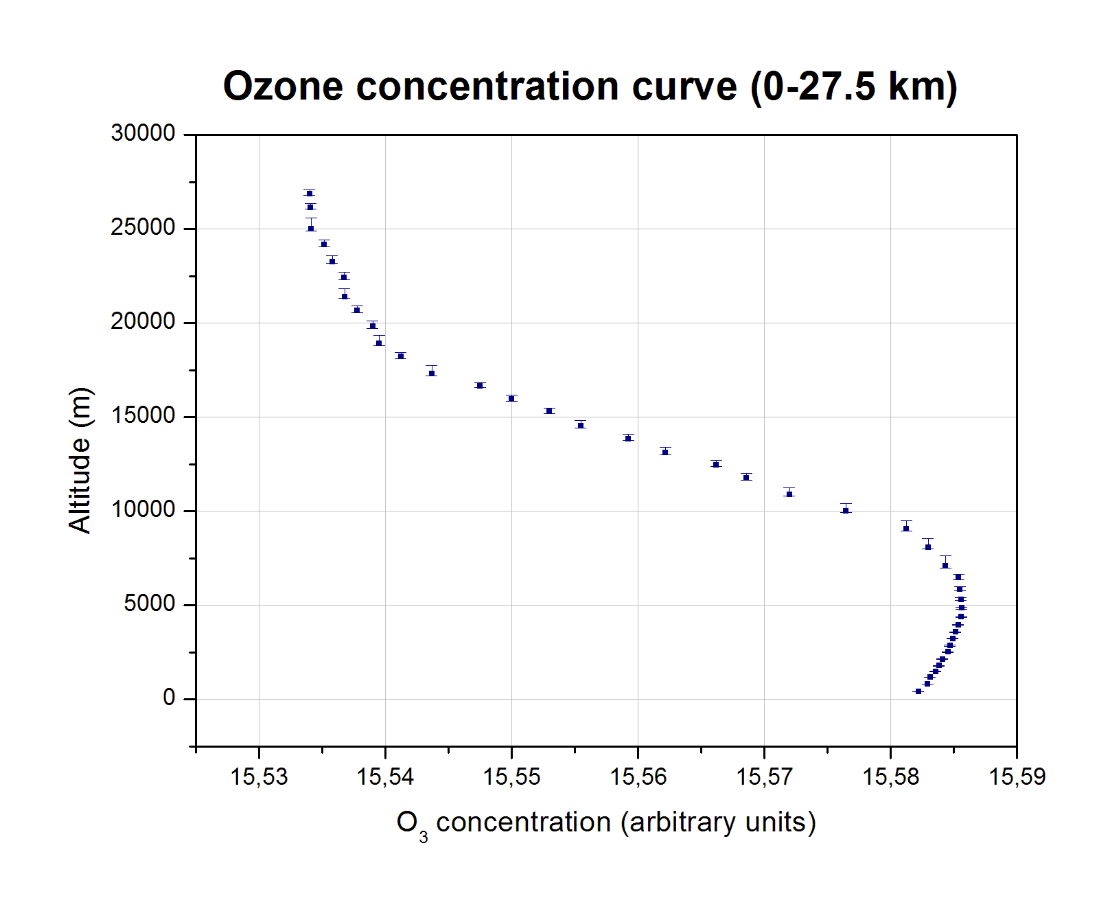

Graph 3: Characteristic concentration curve up to stratospheric Altitudes

As can be seen in the above graph, the density of measurements is noticeably greater in earlier heights. This is attributed to the pump’s function as explained in previous segments. No error bars were included for the horizontal axis (concentration value) considering that the units of measurement are arbitrary.

Another observation worthy of mention is that the derived curve has a smooth profile. This means that there are no outlier values which deviate greatly from the measured values around them. Thus, the hypothesis that the qualitative image produced is somewhat correct could possibly been made.

# IR11BD (CO2 SENSOR)

#### Environmental Performance Ranges

Just like the ozone sensor, IR11BD has its own designated set of environmental variables which must be in a certain range. Specifically, as is expected, the sensorbox temperature was well within the specified range of -20 oC to 55 oC. Again, the relative stability of the temperature makes the calculations easier. The Relative Humidity range indicated by the sensor’s data sheet is 0%-95% so the sensorbox was obviously met the requirements. In the case of pressure, however, the minimum pressure needed for the sensor’s proper function is 300 mbar. Thus, the pump was only able to create acceptable conditions for the sensor during the first hour of flight or up to altitude with ambient pressure about 100 mbar as can be seen in the Sensor Box Variables graph. The measurements taken beyond that point cannot be considered accurate or even valid.

#### Calibration Procedure

In the case of IR11BD, due to the higher concentration of CO2 in the atmosphere and the nature of the sensor, the calibration procedure is easier, less complex and produces better accuracy than the ozone sensor. In this case, there exist a few secondary constants that must be calculated through calibration, but they remain generally stable, so the manufacturer has provided a list of typical values. The main issue caused by not calibrating the sensor arises from the two main constants that need to be calculated separately for every sensor: the Zero and the Span. Essentially, *(the temperature compensation is omitted in this explanation because in this case the contribution is both minimal and easy to calculate thanks to the temperature stability)* the relation between the voltage measurements given by the sensor (denoted x in the equation below), the two constants and the concentration is:

$$C= {\left\{\frac{-\ln\left[1-\left(\frac{1-\frac{x}{Zero}}{Span}\right)\right]}{n}\right\}}^{1/a}$$

Where n, a are two of the secondary constants and C is the concentration. In the two pictures below, it can clearly be seen that the concentration is extremely sensitive to small changes of Zero and Span. x is always greater than 0 and less than 0.3 in the taken measurements, two typical values are taken for n and a. These pictures are two families of concentration functions for different values of Zero and Span respectively

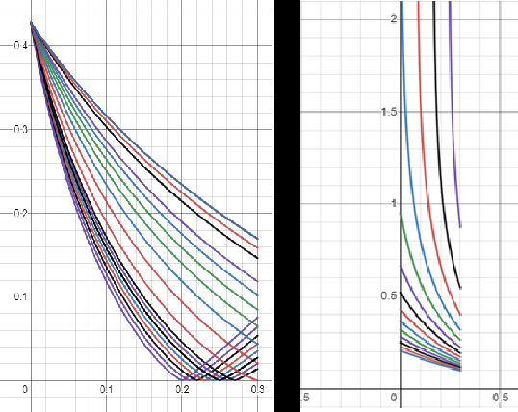

Figure 1: A family of concentration functions for small changes to Zero and Span respectively

As can be seen in the graph above, for very small changes in Zero, the shape (monotonicity and curvature) of the function can change. The minimum of the function changes position. Likewise, for small changes in Span, a great change in scale can be observed.

#### Results

Unfortunately, it can be safely determined that a reliable quantitative depiction of carbon dioxide concentration in the atmosphere is certainly not feasible without proper knowledge of Zero and Span. Additionally, the qualitative image shown below (*which is derived using the same method mentioned in the ozone section)* comes with great uncertainty.

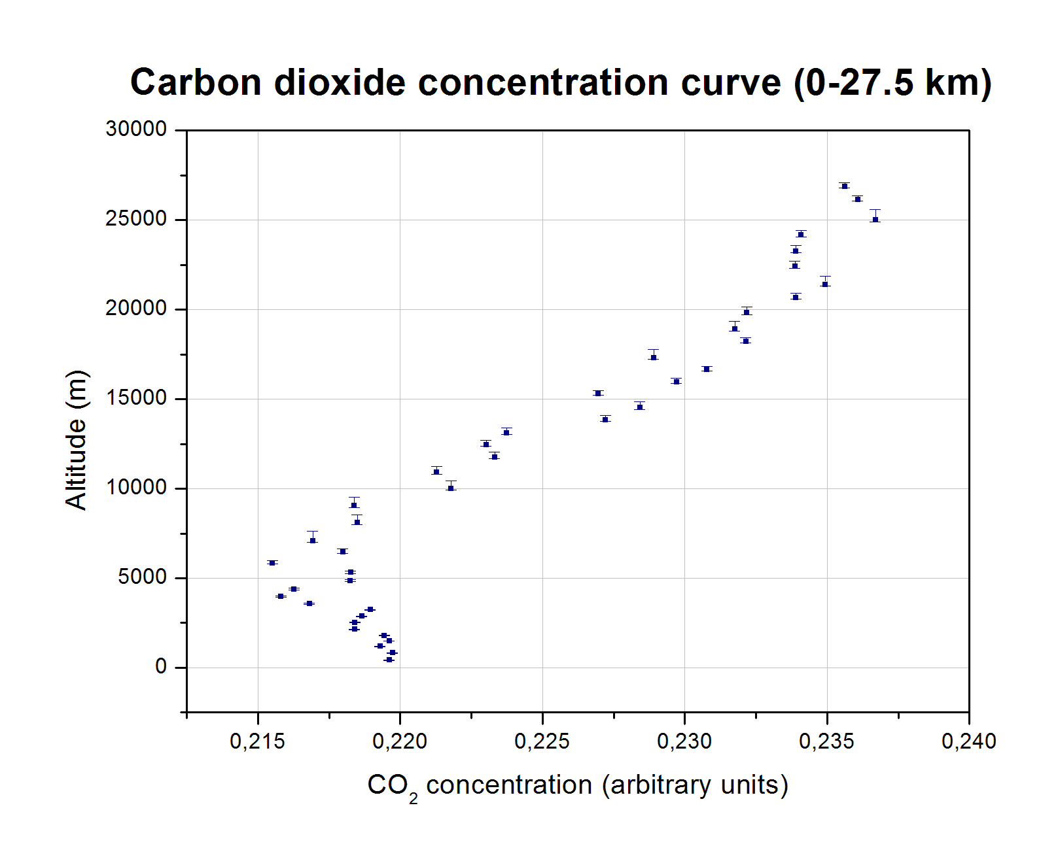

Graph 4: CO2 Concentration curve up to early stratospheric altitudes

As is clear from the presented graph, the same observation about measurement density can be made (that is expected, both sensors were in the same sensorbox). However, the same things cannot be said about the smoothness of the characteristic curve. Again, the measurements tend to follow a specified curve and are not completely random but, in this case, there are obvious gaps and noticeable deviations from the curve.